**Summary**: Triggering Automatic email when an item is updated in the shared folder.

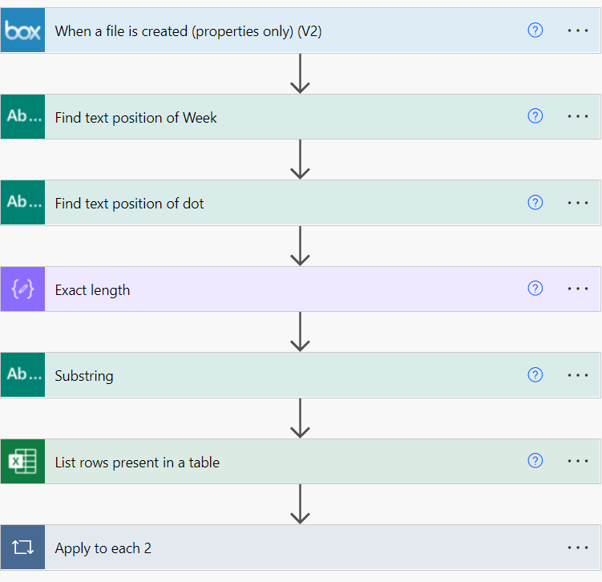

Step 1:

Select the folder to trigger email when an file is created

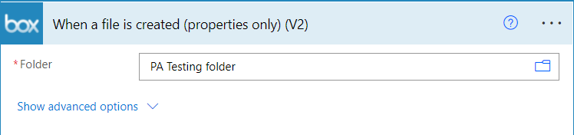

Step 2:

Assuming all the file name has a common word “week” and its subsequent numbers.

This will finds the position for the word “week”

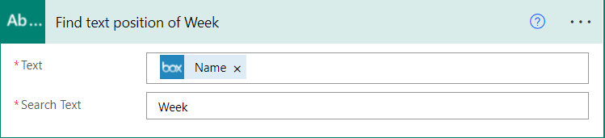

Step 3:

Assuming the word Week and the number were updated at the end of the file name. And this will find out the position of the “dot”

Like: “Forecasting report Week 12.xlsx”

Note: You can avoid step 3 if you are sure on the length of the word you want to pick.

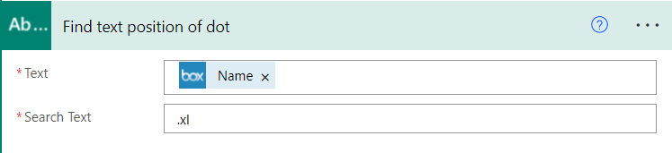

Step 4:

An substring function has been used to get the length of the text.

The purpose of the substring is to find the exact length of a word.

Substring: “sub(outputs('Find_text_position_of_dot')?['body'],outputs('Find_text_position_of_Week')?['body'])”

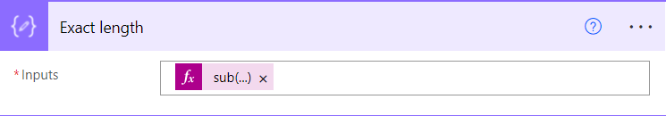

Step 5:

Combining the variable to get the week number. 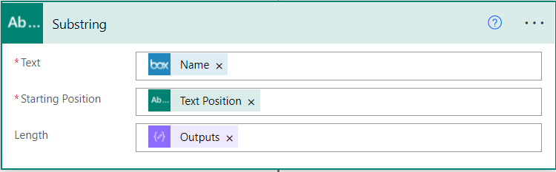

Step 6:

Getting Distribution list from an shared folder.

Note: The DL should be in a table

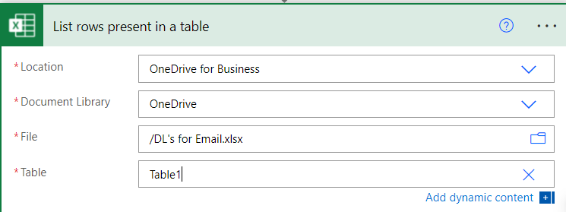

Step 7:

Later Writing the body of the email with the subject

